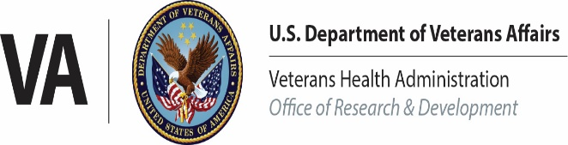

Field Conference Call – Meeting Notes
Monday, October 19, 2020 at 1:30 pm ET

- Welcome Rachel Ramoni, DMD, ScD

Dr. Ramoni welcomed the attendees and highlighted some of the agenda topics.

- ORD Topics Grant Huang, MPH, Ph.D.

- Operation Warp Speed (OWS) updates - COVID-19 Research Updates:
Currently, ORD efforts on COVID-19 trials are focused on starting up sites involved in OWS studies. The Janssen vaccine trial (also called ENSEMBLE) is among the higher priorities in getting through several activities to get sites running and staff in place to run the trial. Sites involved in OWS trials are reminded to ensure that VA medical center leadership (Medical Center Director, Chief of Staff, et al.) are aware of activities and any need for support. ORD leadership have been communicating the importance of VISN and VAMC leadership to reach out to ACOS-Rs on national calls. Additionally, a recent webinar was given to VA and VHA partners summarizing key activities. A recording and slides are available at the ORPPE webinar archive found at: https://www.research.va.gov/programs/orppe/education/webinars/orppe-101520.cfm

- Follow up from Annual NAVREF / ACOS-R Virtual Meeting:
Dr. Huang has convened some ACOS-Rs to help with identifying key topics and priorities for the field. Some items were raised in the recent NAVREF/ACOS-R annual meeting. The intent is to create work groups to help address problems and work toward solutions. More information and opportunities to participate will be communicated when ready.

- Information for Human Resources Activities Jessica Bonjorni
Chief, Human Capital Management
Joyce Deters
Jeffrey Dintelman

As part of recent activities focused on COVID-19, ORD has been talking with Ms. Bonjorni and her team about hiring and other flexibilities/policies that may be available. They were an invited guest to share some information and points of contact as indicated in the slides.

- Research Protections, Policies & Education Molly Klote, MD, CIP

The VA COVID Volunteer List is located at www.va.gov/coronavirus-research. Recruitment materials for the registry will be distributed this week. There are over 1350 volunteers registered as of the date of the call.

- IT Updates Carl Grunfeld, M.D., Ph.D.

Dr. Grunfeld and the IT work group are looking to expand the successful pilot of the Research Wireless Network that uses EDUROAM to connect to the Affiliate, which allows Affiliate approved computers to work while at the VA. If your Affiliate has EDUROAM and you are not able to connect while at the VA and you would like to connect to EDUROAM, please send Dr. Grunfeld:

- a brief summary of the need (e.g., types of Affiliate sites or functions blocked by the VA),
- the numbers of researchers it would apply to,
- and the name of your Affiliate.

The VA still has more laptops that allow research staff to VPN in, rather than CAG. Ask for them.

With regard to the removal of Adobe, if one had it, IT should be adding it back to their computer. Two ways to approach it: 1) Put a ticket request in via the “Your IT” portal and tell your IT people they must restore it. 2) Go to the software center and see if you can download it.

Dr. Grunfeld and the IT group are working on better service for wearables and other patient generated data systems. They did get an OGC ruling that this type of patient accumulated data it is not VA data until downloaded onto a VA computer.

Efforts are on-going to actively add increasing numbers of Research Scientific Computing Devices (aka RSCD by IT) to the local VLAN. The training on adding RSCD to the VLAN was recorded and is available:
https://www.research.va.gov/programs/orppe/education/webinars/orppe-100620.cfm
Please consider doing this. If the demand is significant, we may be able to create a separate Research VLAN like they have to BioMed.

One of the IT members of our joint IT/Research Task Force alerted me that IT is once again changing which FIPS-compliant Flash Drives and External Hard Drives are permitted. If you will be buying a new flash drive or new external hard drive you should buy it from the new list.

FIPS 140-2 Validated Removable Storage Devices:
https://vaww.portal2.va.gov/sites/infosecurity/ess/Configuration%20Guidelines.aspx

- Finance Allen Dunlow

Mr. Dunlow informed the field that FSC has run all necessary reports and that FY2020 has closed. With that, FY2021 should now be open for business. The initial 72 days of ITA funding should process by October 19,2020. If you do not see funds on station within 24 to 48 hours please let Mr. Dunlow and Mr. Verwiel, Deputy Director, ORD Finance, know.

- Service Updates

- BLR&D Updates Christopher T. Bever, Jr., M.D., MBA

- Early announcement of a funding opportunity to be released before the end of the year soliciting proposals to establish an Interagency Preclinical TBI Resource Center. The proposed center will be funded by BLRD but will support all investigators with federal funding for TBI research. The center will support the creation and maintenance of an online catalogue of TBI models, the establishment of common data elements for preclinical studies, the development a plan for a preclinical TBI data commons and support the establishment of an enterprise approach to preclinical TBI research. This announcement is being made to allow interested sites and investigators to begin early planning of proposals that will be due in March of 2021.
- BLRD is currently accepting nominations of outstanding clinician scientists for the Clinician Scientist Award Extension program. Please direct questions to Dr. Kimberlee Potter, Kimberlee.potter@va.gov.
- A reminder that investigators should not contact Scientific Program Managers or review panel members about proposals currently under review. Direct any questions to the Merit Review Manager, Dr. Michael Burgio, Michael.burgio@va.gov.

- HSR&D & QUERI Updates Naomi Tomoyasu, Ph.D.,
David Atkins, M.D.,
Amy M. Kilbourne, Ph.D., MPH

- COVID-19 Updates

HSRD will shortly be soliciting interest in two initiatives:

1) A coordinating center to manage the COVID Treatment Outcomes Collaboratory which will consist of two cores and one project:
    - Data/Methods Core
    - Administrative Core
    - Project: Long-term effects of COVID infection on health and health care utilization.
Please send your interests to: Alexandra.NeuhausFollini@va.gov

2) A committee to identify priorities for studies on the effects of the pandemic on non-COVID health outcomes. We will ask for volunteers to be part of a committee to define the goals, outcome measures and designs for a study to determine the effects of foregone, interrupted or deferred care on health outcomes. Tentative areas for studies include: mental health outcomes including substance use and suicide; acute care outcomes (e.g. stroke, MI, COPD exacerbation); and chronic/preventive care outcomes.

Please send nominations to Stephanie.Guerra@va.gov.

B. CIDER – Updates

- HSR&D Investigator Appointed to PCORI Advisory Panel
Kristina M. Cordasco, MD, MPH, MSHS, with HSR&D’s Center for the Study of Healthcare, Innovation, Policy and Practice (CSHIIP) was among 34 people named to serve on advisory panels for the Patient-Centered Outcomes Research Institute (PCORI). Dr. Cordasco will serve on the Advisory Panel on Healthcare Delivery and Disparities.

- Lung Cancer Screening Program among VA Shark Tank Finalists
Led by Christopher Slatore, MD, MS, (Portland) the VISN 20 Centralized Lung Cancer Screening (CLCS) program was among 15 practices selected to move forward in the competition.

- SMRB Updates:
- Summer 2020 Cycle
- HSR&D’s merit review meetings took place virtually on August 25 - 28, 2020. Scores were released on September 2, 2020.
- Summary statements were released on September 23, 2020.
- Funding decisions and Notices of Intent (To-Fund or Not-To-Fund) were released on October 14, 2020.

- Winter 2021 Cycle
- New and revised RFAs were posted on September 23, 2020 on the intranet site. Please review the RFAs thoroughly to check for any changes in requirements and to ensure compliance. As a reminder the guidance in the RFAs supersedes the SF424.
- HSR&D updated their research priorities. If you plan on submitting an Intent to Submit (ITS) for the Winter 2021 cycle (October 21 – November 4), please make sure you review the updated priorities. The updated priorities can be accessed using the link in the RFAs or here: https://www.hsrd.research.va.gov/funding/PriorityDomains2019.pdf.
- The HSR&D Intent-to-Submit in ART will open on October 21, 2020 and closes November 4, 2020 (at 8:00 pm EST).
- The first day to submit full applications (using Grants.gov Workspace or eRA ASSIST) is November 15, 2020, and the last possible submission day is December 10, 2020.
- HSR&D’s Scientific Merit Review Board and Career Development Award review meetings are both scheduled to take place virtually on March 2 -5, 2021.

- CSR&D Updates Terri Gleason, Ph.D.

Dr. Gleason provided updates regarding the following topics which have more details below.
- Community of Science
- Update on CSRD Clinical Trials on COVID19
- Start of Merit Review Round – Precision Oncology/COVID19 trials
- New Senior Precision Oncology Portfolio Manager
- Announcement to be made for Program Manager Oncology
- John Barnwell Nominations – due February 1 2021
- REMINDER November 1 is Letter of Intent Deadline for Spring 2021 round

- CSRD is convening a new Community of Science effort on October 26 with investigators supported from our COVID19 rapid response proposals. The intent of the meeting is for CSRD PIs to share summaries of the objectives of their COVID studies and any progress to date. In addition, we will provide information on available resources, including the phenotype library, biorepository, and strategic initiatives from the Office for Research Policy, Protections, and Education. There will be breakout sessions where awardees will discuss plans for advancing COVID research. This is our first time bringing together all CSRD investigators working on COVID research and we are excited to bring this new scientific community together. Outcomes will also be shared. BLRD COVID-19 awardees have been invited to listen in on the meeting. We anticipate a total of 23 CSRD PIs and 34 BLRD PIs

- COVID-19 CLINICAL TRIALS PROGRESS:

The HITCH trial which focuses on degarelix has 14 sites enrolling inpatients; great thanks to local site investigators and staff to make enrollment successful
CURES-1, a trial on convalescent plasma has 25 sites setting up, Houston first to go live; we hope they have local support to make this run smoothly. Great thanks to Pathology Services in the administration of plasma for this important study.
A new announcement is being developed to consider under the VA CURES platform, which will allow new clinical trials to be evaluated for potential fit within the VA CURES therapeutic lanes, prophylaxis/COVID19 exposed, outpatient/COVID19+, inpatient/COVID19+. We hope to disseminate this announcement within the next few weeks, and the intent will be generate as many study ideas as possible so that a ranking process can be conducted to set a priority order.

- Fall Merit Review Round of meetings are starting the week of the ORD Field Call. In CSRD, due to the high priority focus on new treatments for precision oncology and COVID-19, we have set up meetings to start this week with the goal of considering the evaluations of merit to allow for quicker start up if trials are highly rated.

- New Senior Program Manager for Precision Oncology

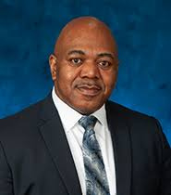
Clinical Science Research & Development Service (CSRD) is delighted to announce the new appointment of Dr. Kenute Myrie to the position of Senior Program Manager for Precision Oncology.
Ken has been an amazing asset in the past as Scientific Portfolio Manager and Career Development Program Manager for Biomedical and Clinical Services. His stellar career and leadership includes the establishment of highly engaged career development annual symposium as well as stewardship for oncology for both services. More recently he was detailed to the Office of the Secretary in the Partnership Program. In this detail, he developed and expanded a critical partnership with the Prostate Cancer Foundation as well as other important program offices. All of this contributed to his leading the VA’s newly defined priority for Precision Oncology. We will look forward to his coordinating this priority research work across the Office of Research & Development for the Department and beyond, so that advances result in the care and treatment of our Veterans with cancer.

- It is anticipated that CSRD will post an announcement soon for Ken’s replacement as Portfolio Manager, and that will be shared with the field as soon as it is available.

- The John B. Barnwell Award (Barnwell Award) is the Clinical Science Research and Development (CSR&D) Service’s highest honor for outstanding achievement in clinical research. Applications are due COB February 1, 2021.

The Barnwell Award is given for outstanding scientific achievements in clinical research that advance the diagnosis, prevention and/or treatment of diseases and disorders in the Veteran population.

Nominations may come for the VA medical center or CSR&D can invite researchers to submit an application. All applicants must apply through their local R&D Office. To be eligible for the Barnwell Award, nominees must meet specific qualifications please review the program guide and instructions posted on the website for further details or contact Dr. Mark Roltsch if you have questions. His email is mark.roltsch@va.gov
The information is found on the ORD website just search Barnwell Award
The website is https://www.research.va.gov/services/csrd/research-awards.cfm?_ga=2.56572011.1990953416.1542631466-377307463.1536175624#barnwell

- LETTERS OF INTENT are due Nov 1; BL and CS including CADE and clinical trials.

- RR&D Updates Patricia A. Dorn, Ph.D.

Service updates for RR&D regarding new Center and REAP, as well as review activities were provided. More details are included in these notes.

New RR&D Center: Enhancing Community Integration for Homeless Veterans, VA Greater Los Angeles

Under the Direction of:

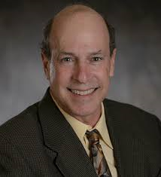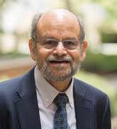
Michael F. Green, PhD Robert S. Kern, PhD Stephen R. Marder, MD

Background:
- Los Angeles County still has the largest number of homeless Veterans in the US (about 4,000)
- Permanent housing is a necessary, but not sufficient condition for community integration
- Research has shown that providing housing and VA services, on average, does not change a Veteran’s community integration

Components of Community Integration:
- Social / Family Integration
- Work and Productive Activities
- Daily Living Skills

The Center Mission:
To understand and to improve community integration in homeless and recently-housed Veterans.

The Overall goal is to improve the lives of Veterans who are trying to recover from homelessness by:
- Understanding the intrapersonal determinants and mechanisms of community integration
- Developing and validating interventions (psychosocial, psychopharmacological, other) that enhance community integration for these individuals
- Considering the contextual, social, and environmental factors that influence community integration

Leadership Team also part of:
- VA Desert Pacific Mental Illness, Research, Education, and Clinical Center (MIRECC)
- UCLA Department of Psychiatry and Biobehavioral Sciences

Partnerships with Other Key Groups Nationally and Locally:
- National Center for Homelessness Among Veterans
- California Policy Lab / Public Policy Dept. UCLA
- VA / UCLA Center for Resilience and Recovery
- GLA Community Engagement and Reintegration Services

NEW RR&D REAP: REhabilitation Promoting Prevention And Improved Resilience (REPPAIR), VA Boston

Under the Direction of:

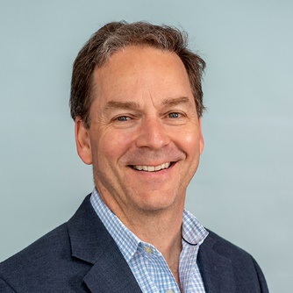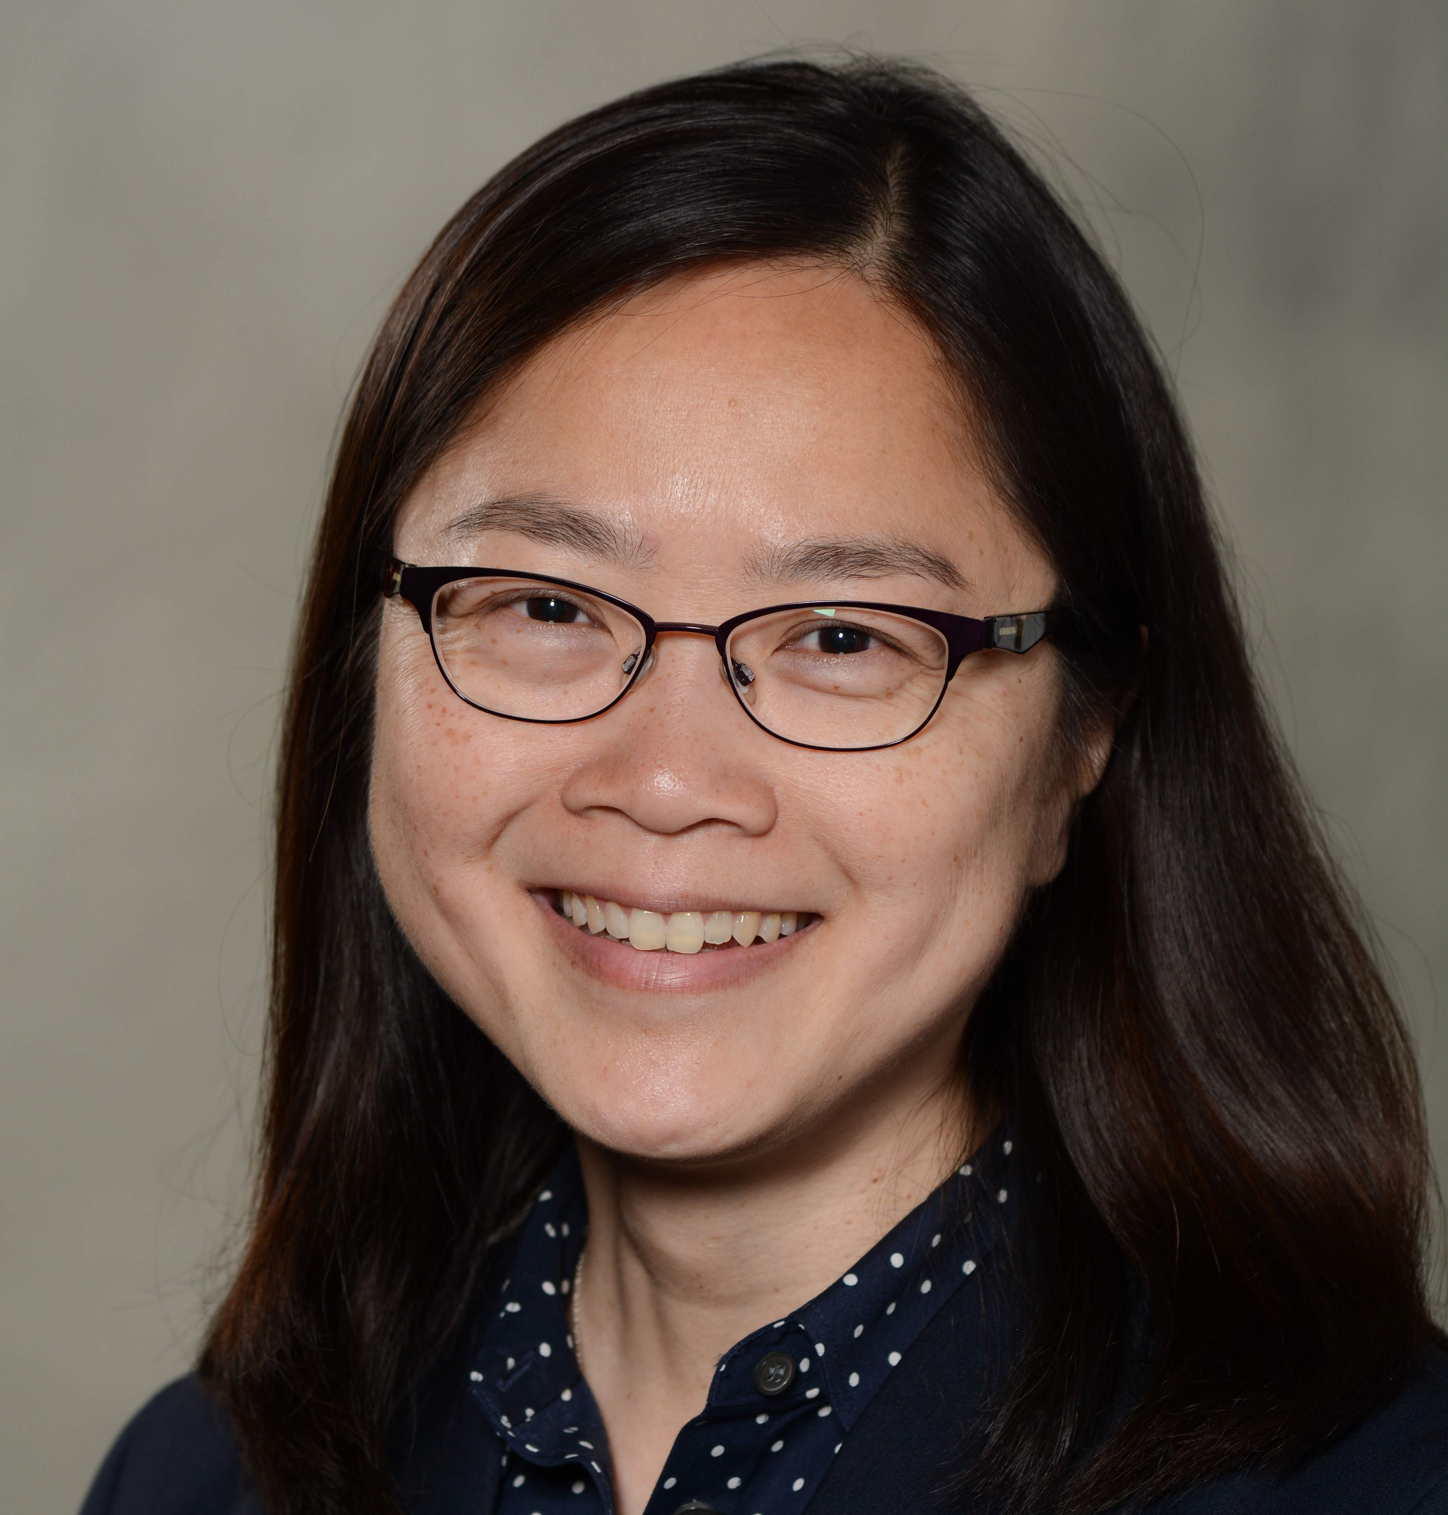
Jonathan F. Bean, MD, MPH Marilyn L. Moy, MD, MSc Erica Scioli, PhD

REPPAIR Challenge:
- Veterans
  - mean age: 64 years
  - more severe impairment & limitation than civilians
- Maintaining function
  - highest priority of older patients seeking care
- Rehabilitation serves proactively as preventative care
- Priorities reflect VHA strategic goals

Approach Focuses on the 3 M’s
- Mind: Cognitive Function
- Mobility: Physical Function
- Motivation: Behavior Change

Supports Aging Friendly Healthcare Initiative
- Shared principles of Geriatric Care
- Motivation & behavior change component of rehabilitation

REPPAIR will position rehabilitation as a model of secondary preventative care through innovation and enhanced focus on the 3 M’s
- Efficacy Testing
- Biotyping & Phenotyping Responsiveness
- Confirmation using Big Data
REPPAIR Team from Varied Research Groups within VA Boston:
- GRECC/PMRS/Geriatrics
- Medicine/Pulmonary
- National Center PTSD
- MAVERIC (Massachusetts Veterans Epidemiology Research and Information Center)
- NeRVe (Neuroimaging Research for Veterans Center)
- CHOIR (Center for Healthcare Organization and Implementation Research)
Partnerships:
- Harvard University Medical School
- Boston University
- Boston Medical
- Brigham & William Hospital
- Beth Israel Deaconess Medical Center

Review Updates

SCIENTIFIC REVIEW TIMELINES (refer to applicable FOA/RFA for details):
Please continue to contact RR&D for guidance and to ask questions.

Center and Research Enhancement Award Program (REAP):
- Application deadline - August 15, 2019
- Scientific Review - October 29-30, 2019
- Scores and Summary Statements – December 2, 2019
- Administrative Review/Site Visits - November 2019 through October 2020
- Intent-to-Fund notifications – Subsequent to site visit

Summer 2020 - Merit, Career Development and Research Career Scientist:
- Intent-to-Fund notifications sent October 6, 2020

Fall 2020 – SPiRE:
- Updated RFA published – July 1, 2020
- LOI and Waiver Request deadline – August 3, 2020
- Last possible application submission deadline (no changed/corrected applications after this date) – September 10, 2020
- Scientific Review – October 22, 2020
- Scores and Summary Statements released – November 12, 2020
- Intent-to-Fund notifications – by late November 2020

Winter 2021 - Merit, Career Development and Research Career Scientist:
- New RFAs published – September 28, 2020
- LOI and Waiver Request deadline – November 2, 2020 (Nov 1 falls on a Sunday)
- Last possible application submission deadline – December 10, 2020
- Scientific Review – February 18-26, 2021
- Scores released – March 2, 2021
- Summary Statements released – March 22, 2021
- Intent-to-Fund notifications – by mid-April 2021

NOTES REGARDING eRA:
- Please note that although the SF424 Application Guide (R&R), FORMS E package (OMB Number: 4040-0001) have an expiration date of October 31, 2019, NIH has notified VA-ORD to continue using this form set. eRA is not ready to support the new forms until NIH releases FORMS-G that will also include the new Unique Entity Identifier (see below). There is no timeline set for this yet.
- A new Biographical Sketch template (OMB No. 0925-001 and 0925-002 (Rev. 03/2020 Approved Through 02/28/2023)) is available. The new template must be used for all submissions beginning with the Fall review cycle. The Biographical Sketch template with an expiration date of March 31, 2020, will no longer be accepted.
- ACTION REQUIRED: Unique Entity Identifier (UEI) will replace the D-U-N-S® number in December 2020. Go to gsa.gov/entityid for details.
- The NIH has announced a new eRA Commons login option. Please visit their web page Two-Factor Authentication: Accessing eRA Modules via login.gov for details.
- ORD has learned that the feature that allows users with the signing official (SO) role to view summary statements and the overall impact score on the eRA Commons Status Information screen was not implemented for VA-ORD applications. NIH is working to make this available, but we do not yet have a timeline for completion. Reference Guide Notice NOT-OD-20-126.
  - Until this is resolved, RR&D will continue to send copies of summary statements to the research offices along with the review outcome report.

